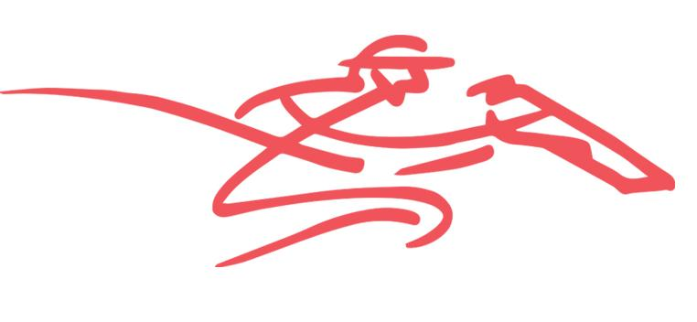
The Trial Files

We at the Trial Files would like to respond to some statements made today about our service.
First of all, we feel it necessary to say that we respect the blog from Steve and he has highlighted a couple of things we could have done better when starting this project. We have learnt a lot from this venture and continued to grow as an organization.
Approximately 18 months ago we first began to document our trial reviews and formulate them into a service provided for punters. We always wanted to be an information provider and that was the intention when we started, to help punters by providing valuable information on trials. It was only through constant feedback that our followers wanted some sort of selection table at the top of the page, highlighting which horses to follow and which horses impressed at the trials.
We did it for all that period of time until just last week FREE. The entire service was FREE – Trial Reviews, Periodic Futures Fixed Odds recommendations, Major Carnival Previews and also our Blackbook service which would be provided every day a horse from that book was an acceptor.
This has taken up a substantial amount of blood, sweat and tears to get the service to the standard it has become and we stand behind its success.
As we said any day a recommended bet was provided we would offer a preview of the race including our Trial Review with quite substantial detail of the way we saw the race panning out. Naturally with any sporting event other matters can affect results but we’d like to think the time taken to produce that offers punters a decent perspective of the potential outcomes. Nothing is given however.
As you know, after blackbooking a horse we would explain our advice to punters and either recommend a play in our template or suggest you consider a bet without being that confident in the race preview. Because our previews go out in the mornings, sometimes not all Fixed Odds markets are available across the various betting providers.
Therefore it was not always easy to suggest unit plays on horses without a price. We have endeavoured, where possible, to enlighten readers with any information through the day if able on Twitter.
On occasions we have suggested a play on a horse at fixed odds to start the day where that was already being offered in the market. That was often the case like weekends where early prices are provided. Otherwise the Betfair SP has been used, which has more often than not been to our detriment as most of our runners have firmed in markets rather than drifted. For long periods of time we were also advising our subscribers to use Betfair.
In the case of Wild Charger, we were very confident the horse would run well and provided valuable information to assist punters in finding him at a big price. The $70 was the Betfair SP and one can easily find this at the following link: https://www.betfair.com.au/racing/thoroughbreds/ascot/race-8/27088805/view/645.2.100778147. As our WA form analyst is, not surprisingly, located in WA it was often the case that we had to send the preview before he was even awake and thus on occasions comments such as the one below would be made in lieu of a unit play:
“WILD CHARGER looks to have settled into his new surrounding well and if he is decent odds is also worth an each way bet.”
One of the huge positives with our new service is that we are able to, and will be, providing SMS bets much closer to race times to ensure we are able to assess odds.
We received substantial response from subscribers who backed WILD CHARGER at the big odds available and we included a very small bet on him in our results spreadsheet. This was perhaps the wrong thing to do and a mistake on our behalf. We unreservedly apologise if this one result has meant you have had a misguided opinion of our service.
On that note, on the same token in a bid to be fair, throughout our 18 months in operation we have highlighted a number of price sensitive bets in our previews that have not gone into our results.
Now that we have teamed with Horse Racing Genius, we feel we can even better provide a reflection of our tips chances with SMS coverage where our preview may go out prior to odds being shown. It will now be much easier to reflect accurate results as we nominate prices when giving selections.
Sometimes in the past, we have made recommendations of a bet where no price was available simply because we like its chances. Often they would shorten and if successful we’d place that shorter price (Betfair SP) into our result. That is a lower result that the opening price offered which meant our results were affected negatively.
There are dips in results. Winning and losing recommendations are included in graphs. From the graphs we have shown during our time, it isn’t always a winning period. No one could ever suggest that in any form of punting. We doubt anyone would propose that. We had a flat period at the start of the year and while not pleased we couldn’t find winners, we accept that that occurs.
All of our blackbook previews were displayed on The Trial Files website and will continue to be so including our Trial Reviews which form a substantial framework of everything we provide.
We only started seeking a subscription recently. Should anyone feel they do not wish to maintain their service we are 100% happy to acknowledge that we have made and error here and we are very happy to offer anyone, and everyone, a refund if they so desire.
We’d like to thank all those who have supported us during our time so far - be they via email, twitter or spoken word. That is very much appreciated. We feel we have gained the respect and trust of all our followers over the last 18 months and we thank you for all of that.
The three of us – Tom, Matt and Mitch – have the best intentions and seek to act in an honest and trustworthy fashion. We are extremely embarrassed by this situation and take 100% responsibility for the mistake. The three of us hope, and believe, that enough of you know us and think enough of us as individuals to move forward with our service.
We are committed to ensuring our results can be 100% trusted and are completely transparent. For those who choose to take a refund and move on we totally understand this decision and wish you all the very best for the future.

